**mySIKAP Use Case**



**Activity Diagram**

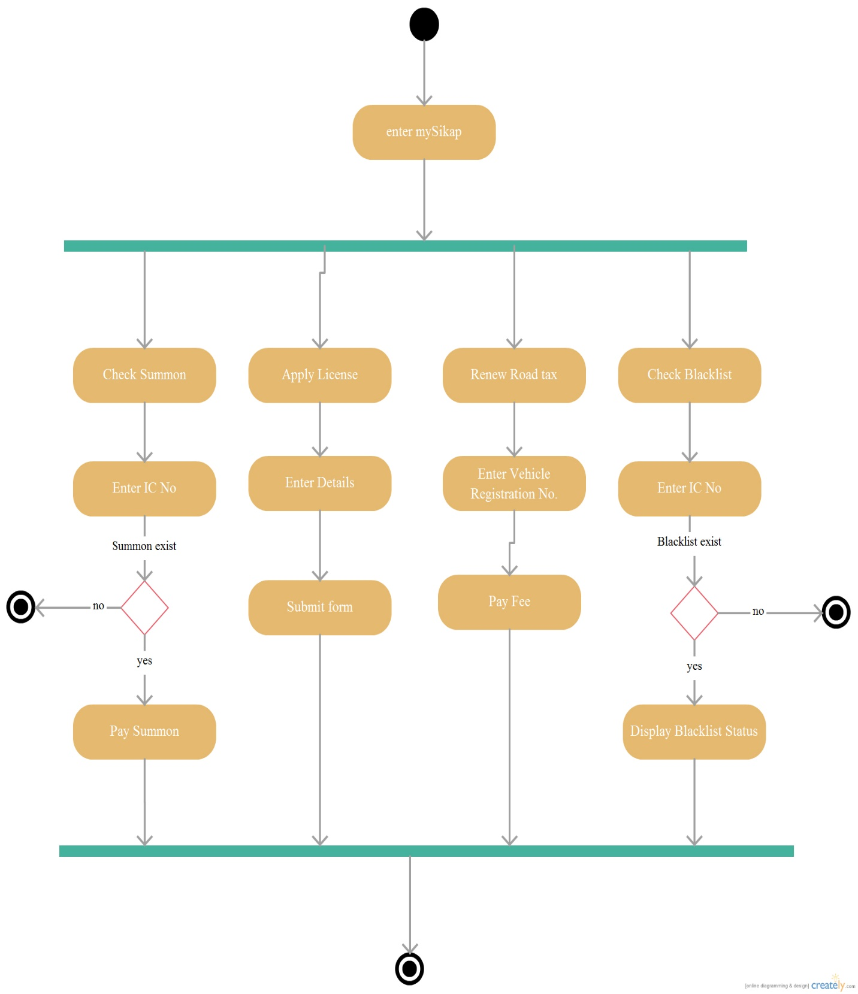

**Apply License Use Case**

**Activity Diagram**



**Sequence Diagram**



**Check Blacklist Use Case**

**Activity Diagram**



**Sequence Diagram**



**Check Summon Use Case**

**Activity Diagram**



**Sequence Diagram**



**Login Use Case**

**Activity Diagram**



**Sequence Diagram**



**Manage Account Use Case**

**Activity Diagram**

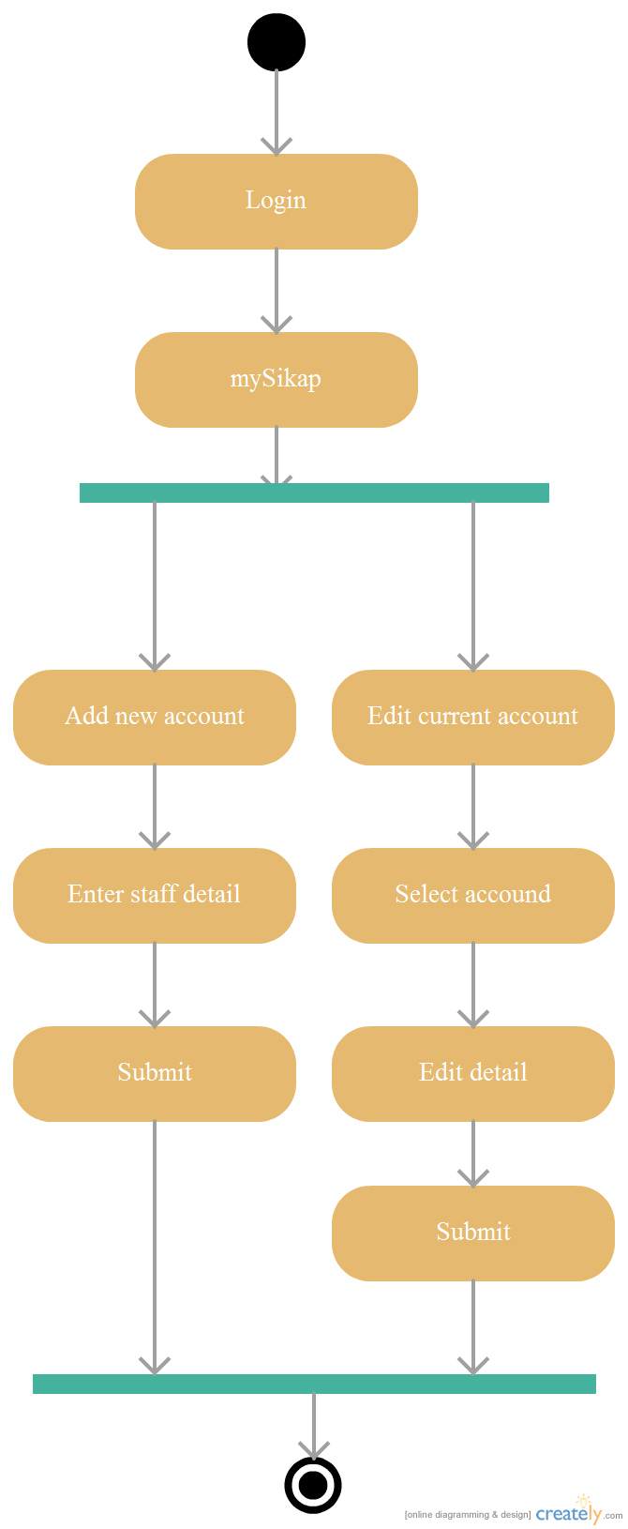

**Sequence Diagram**



**Manage Blacklist Use Case**

**Activity Diagram**

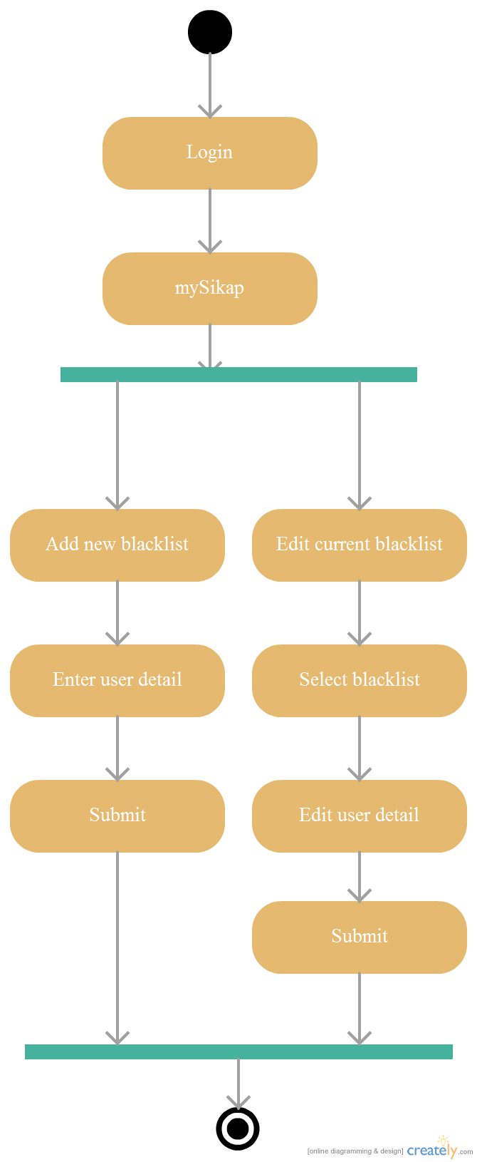

**Sequence Diagram**



**Manage License Use Case**

**Activity Diagram**

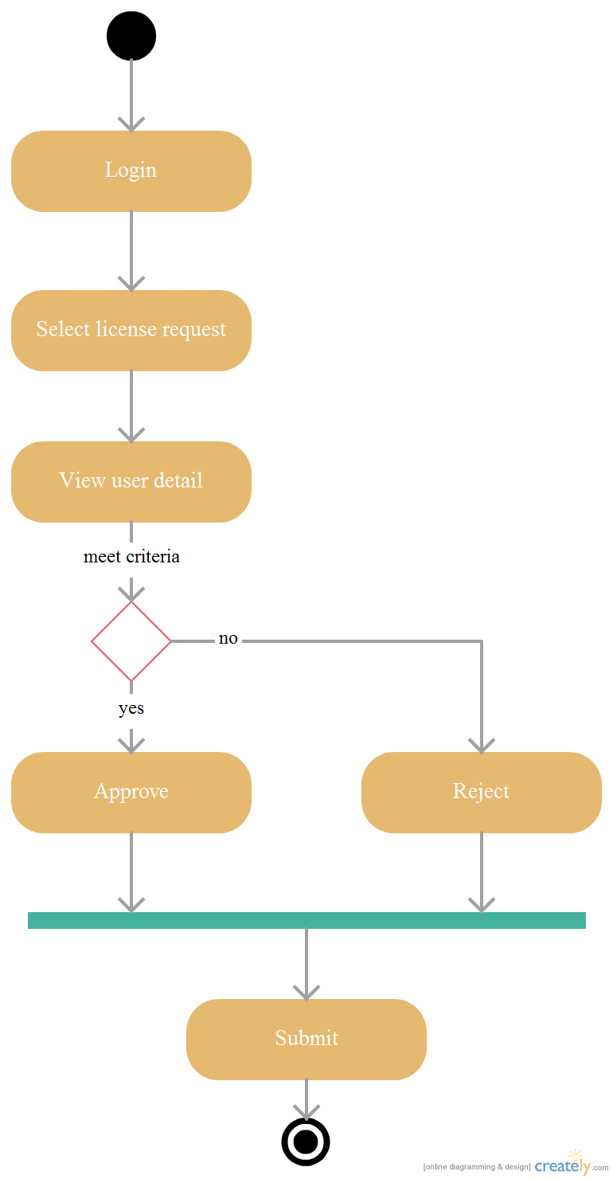

**Sequence Diagram**



**Manage Roadtax Use Case**

**Activity Diagram**

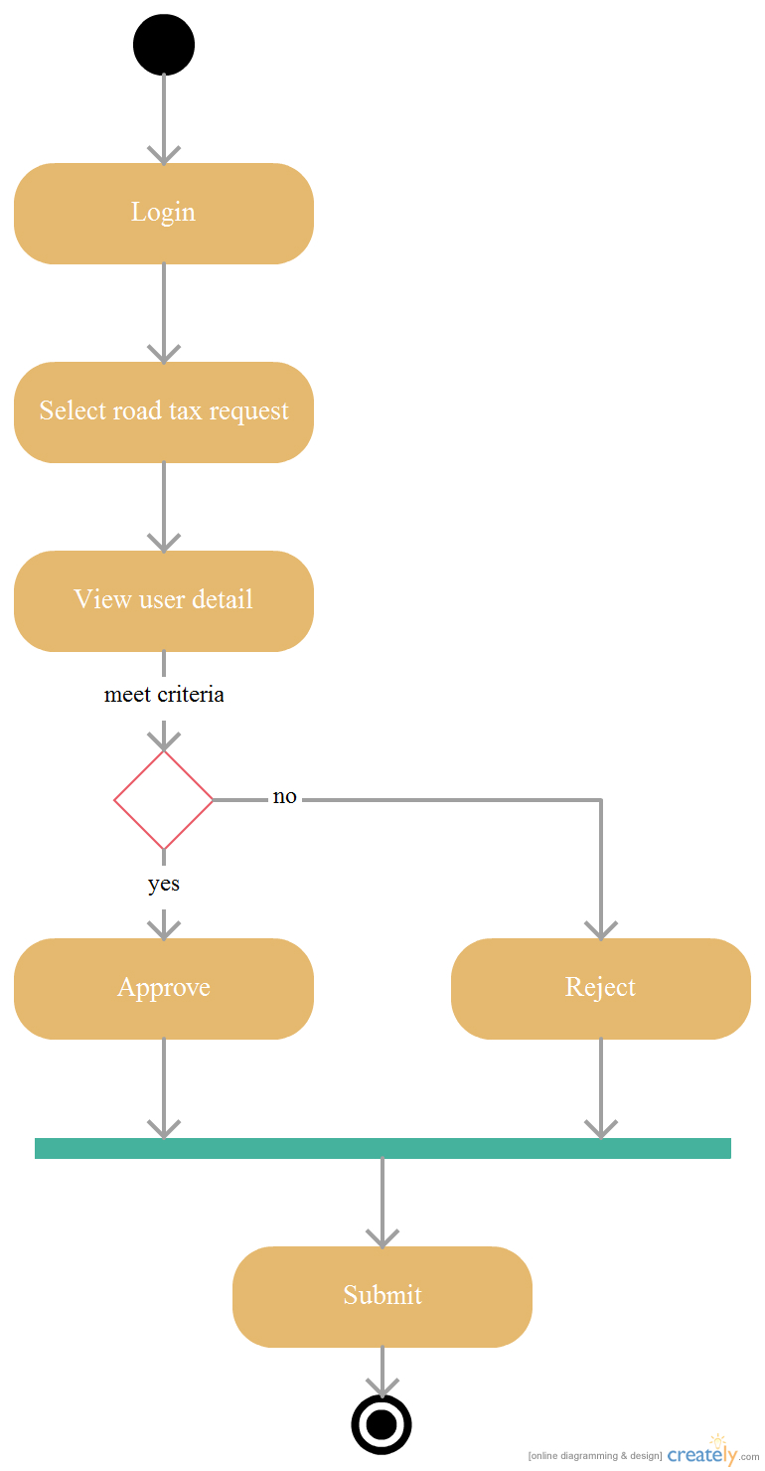

**Sequence Diagram**



**Manage Summon Use Case**

**Activity Diagram**

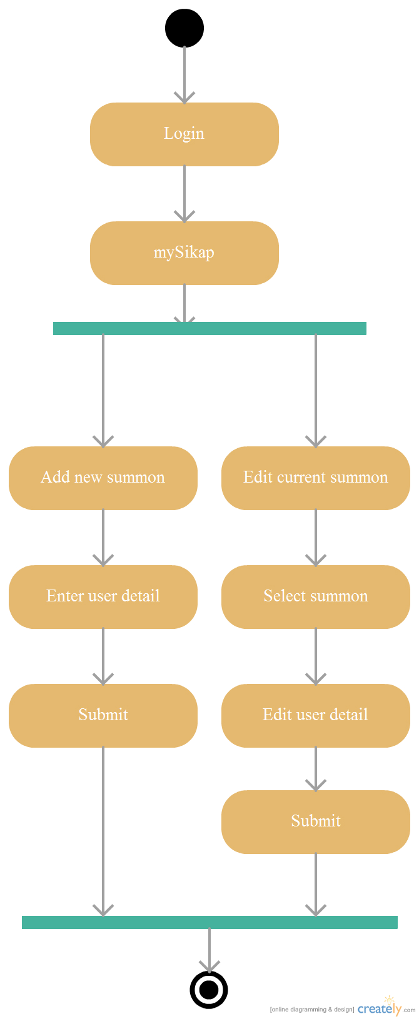

**Sequence Diagram**



**Renew Roadtax Use Case**

**Activity Diagram**



**Sequence Diagram**



Index

1.